Table 1: Slices and delay for Adder

|  |  |  |  |
| --- | --- | --- | --- |
| Parameter: **DSIZE** | BIT-WIDTH | No of LUT slices | Delay in ns |
| 8 | 8 | 8 | 5.725 |
| 16 | 16 | 16 | 5.877 |
| 32 | 32 | 32 | 6.181 |
| 64 | 64 | 64 | 6.789 |

Table 2: Slices and delay for Multiplier

|  |  |  |  |
| --- | --- | --- | --- |
| Parameter: **DSIZE** | BIT-WIDTH | No of LUT slices | Delay in ns |
| 8 | 8 | 41 | 8.550 |
| 16 | 16 | 177 | 9.955 |
| 32 | 32 | 737 | 11.780 |
| 64 | 64 | 3009 | 13.845 |

Evaluation 1

Adder Module

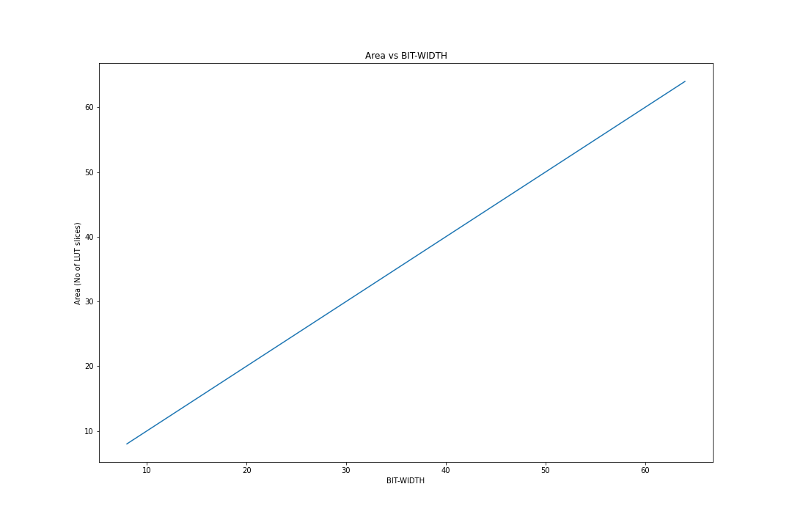

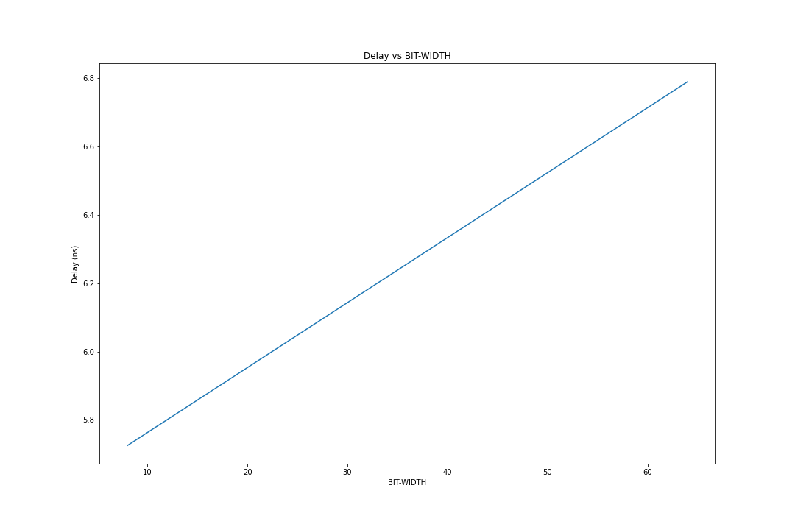

Multiplier Module

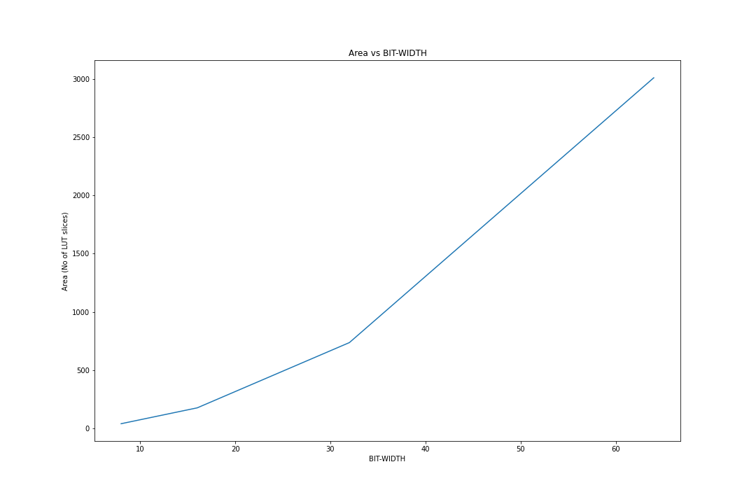

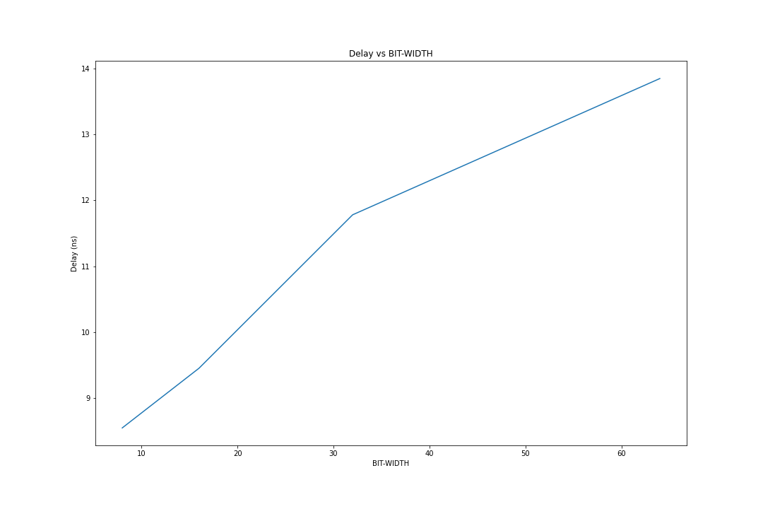

Table 2: Slices and delay for ALU Module

|  |  |  |  |
| --- | --- | --- | --- |
| Parameter: **DSIZE** | BIT-WIDTH | No of LUT slices | Delay in ns |
| 8 | 8 | 16 | 6.856 |
| 16 | 16 | 32 | 7.286 |
| 32 | 32 | 64 | 7.931 |
| 64 | 64 | 128 | 8.845 |

Evaluation 2

ALU Module

